CMPS 312 Mobile App Development
Assignment 3
Student Name | Carmela Cassandra Chavez
Student Id | 202206774
Email | Cc206774@qu.edu.qa
Grading Rubric - - In the Functionality column please specify either: Working (completed x%), Not Working (completed x%) or Not done.
Criteria | % | Functionality* | Quality of the implementation | Student Score
Implemented the Product List Screen with API-based search, filter, and add-to-cart functionality | 50 | Working – Completed 100%
Implemented the Product Details Screen with add-to-cart and add-to-favorites functionality using Dio | 10 | Working – Completed 100%
Implemented the Cart Screen with item deletion, quantity update, and total calculation through Dio calls | 20 | Working – Completed 100%
Implemented the Favorites Screen with navigation to product details using Dio to manage favorite products | 20 | Working – Completed 100%
Total | 100
Not uploading Testing Sheet with screenshots | -15
Copying and/or plagiarism or not being able to explain or answer questions about the implementation | -100

Possible grading for functionality:
- Complete and Working (get 70% of the assigned grade),
- Complete and Not working (lose 40% of assigned grade)
- Not done get 0.
- The remaining grade is assigned to the quality of the implementation.
- Must submit screenshots in this Testing-GradingSheet.docx (otherwise - 15pts).
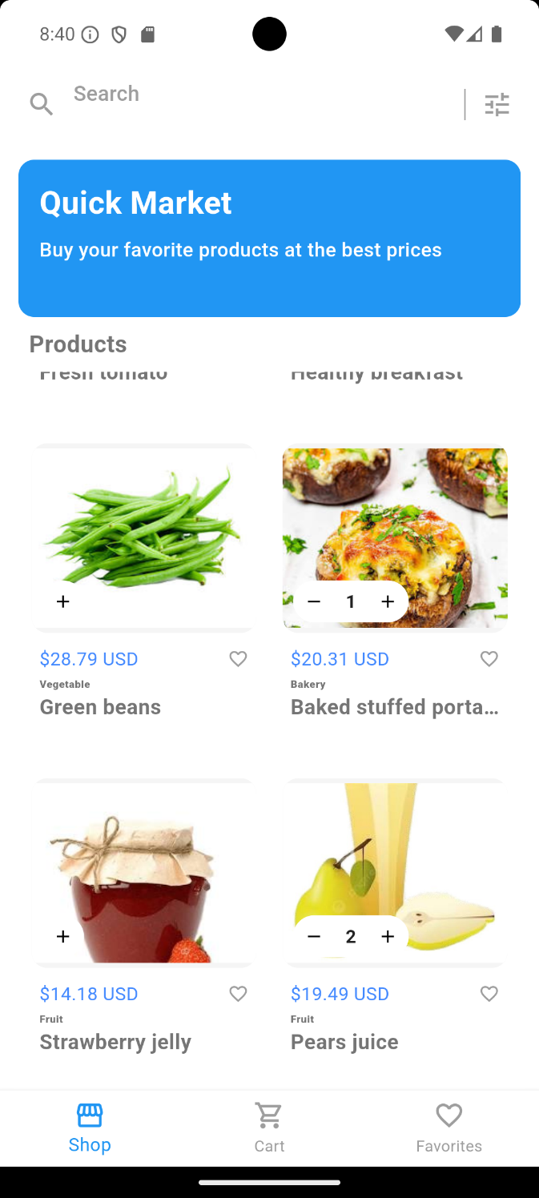 | 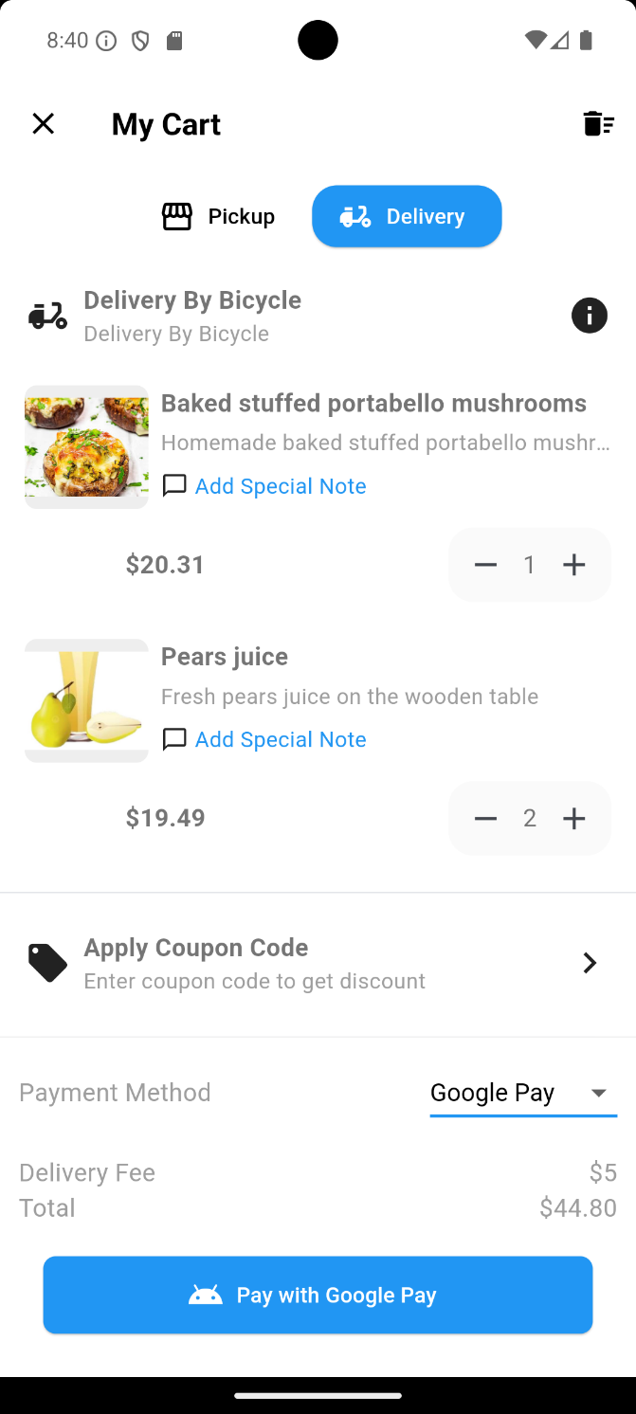
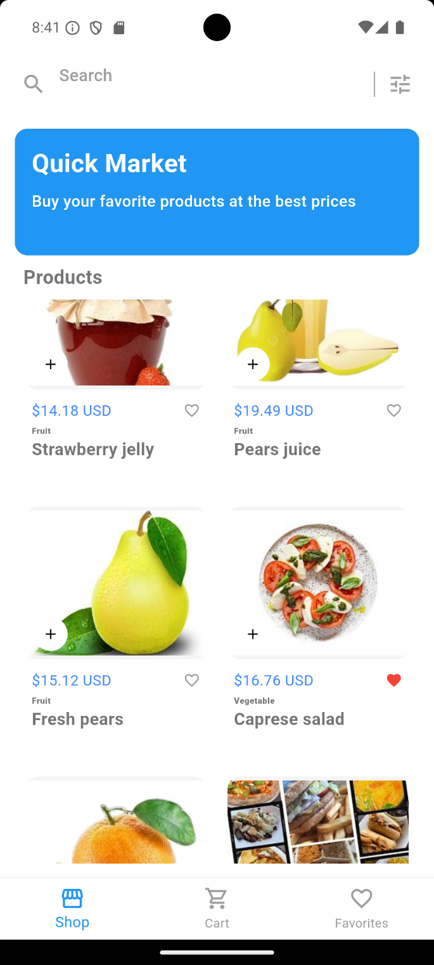 | 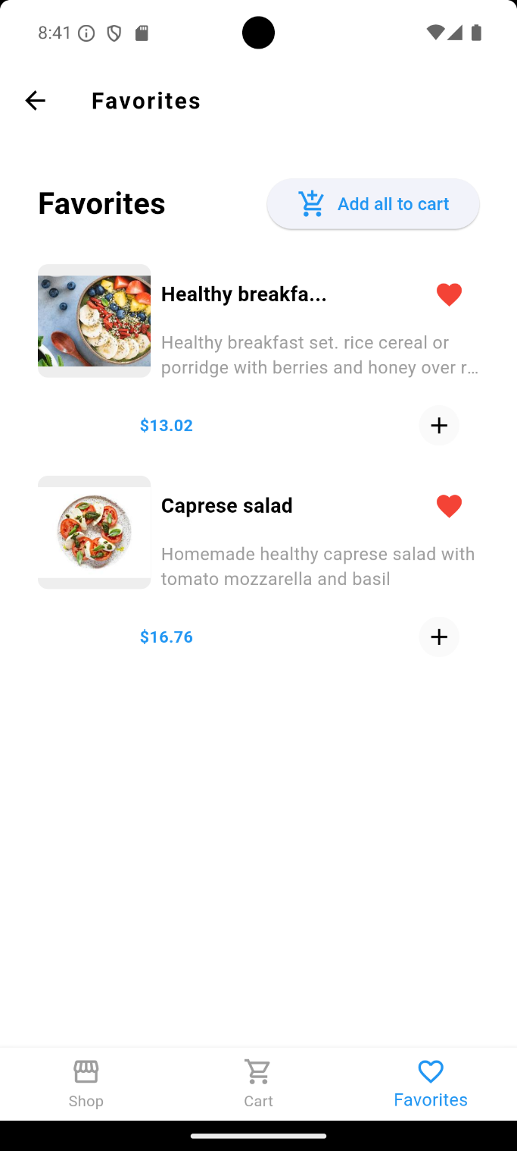
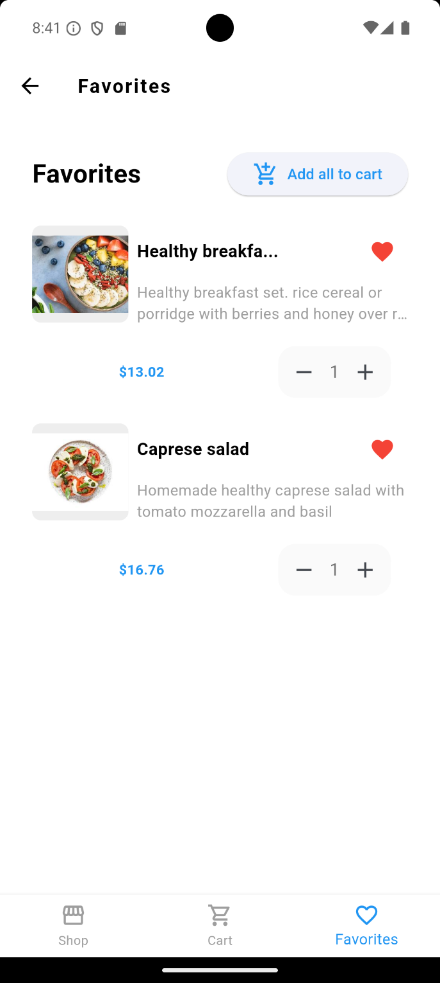 | 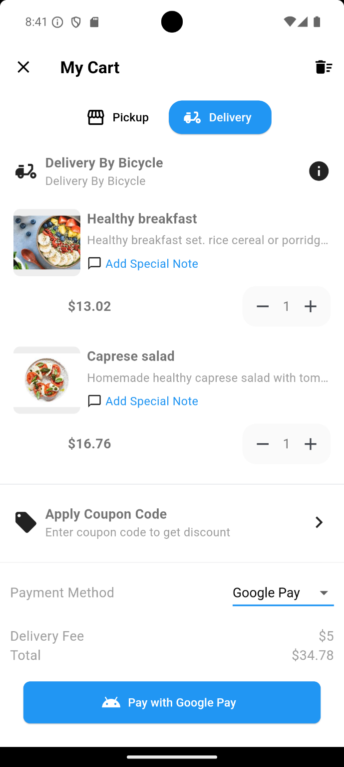
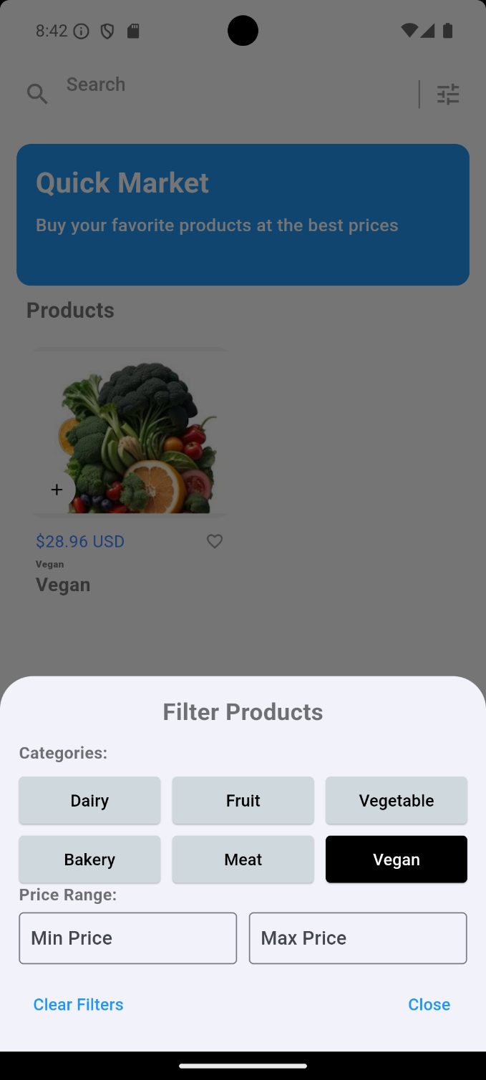 | 